How to Replace the Pedal Crank Assembly
Instructions:
- Remove the front seat cushion bottom.
- Remove the front white seat board by unscrewing the screws that hold it down.
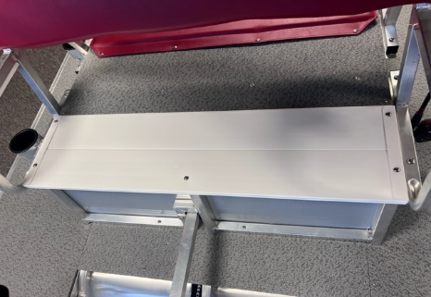
- Find the end of the chain guard frame and loosen.
- Take out the screw that attaches to the front of the doghouse.
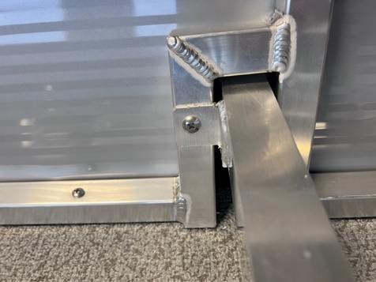
- Take out the screw that attaches to the front frame.
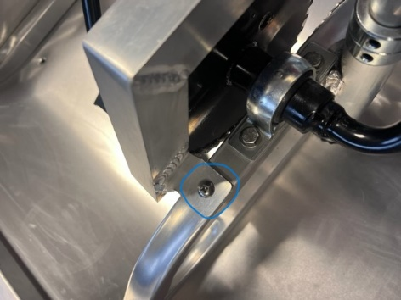
- Drill out the rivets on the white chain guard plate.
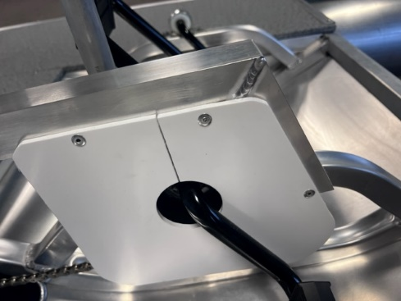
- Remove the white chain guard plate from the pedal crank shaft.
- Pull out the chain guard aluminum frame.
- Loosen the 6 bolts that hold the pedal crank down.
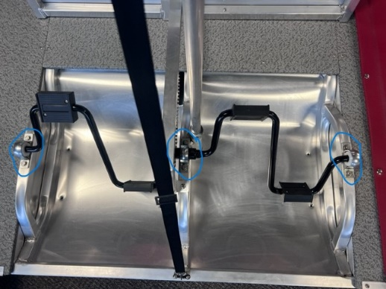
- Remove the pedal crank from the chain.
- Put the new pedal crank into position and align the drive chain on the sprocket.
- Bolt down the new assembly.
- Install the chain guard aluminum frame back to the boat.
- Rivet the existing white chain guard plate back to the aluminum frame or if you ordered a new one, rivet that one back to the frame.
***Note: If you notice a weird noise coming from the pedal crank assembly after replacing the chain guard, please make sure the white plate is not hitting the chain. If so, bend the plate outwards and the chain guard aluminum frame until it does not hit the chain.

