How to Install the Side Lounge
Instructions:
- Lay out all the side lounge parts.
- Align the cushion with the pre-drilled holes on the side lounge bracket.
- Flat side of the cushion faces down and the rounded end faces up.
- Use the shorter screw to screw the cushion in place. 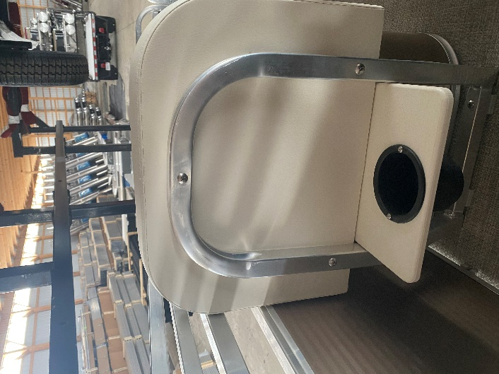

- Align the side lounge with the edge of the storage box.
- Insert the self-tapping screw using a #2 square bit.
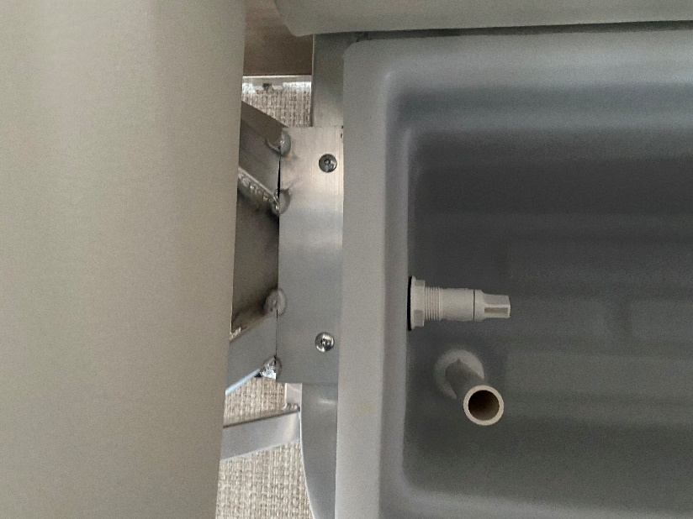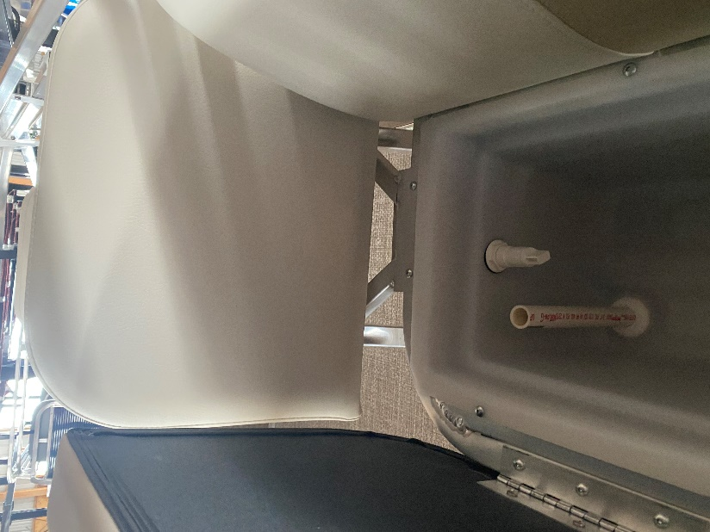
- Align the spacers in between the pre-drilled floor holes on the side lounge.
- Use long screws to screw into the pre-drilled floor holes on the side lounge.
