How to Replace the Chain Guard Assembly
Instructions:
- Remove the front seat cushion bottom.
- Remove the front white seat board by unscrewing the screws that hold it down.
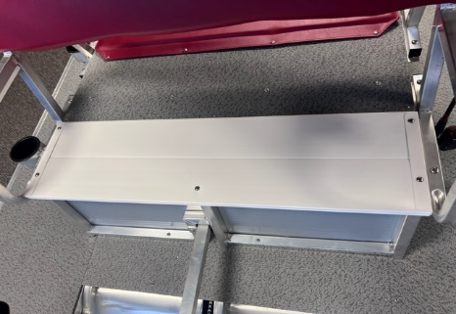
- Find the end of the chain guard frame and loosen.
- Take out the screw that attaches to the front of the doghouse.
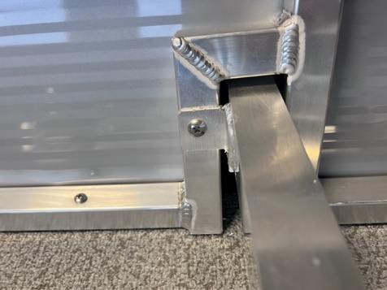
- Take out the screw that attaches to the front frame.
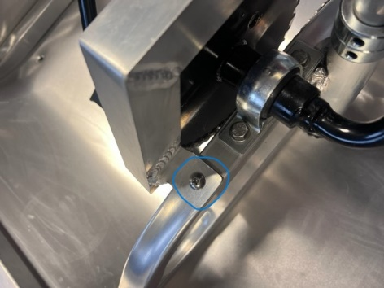
- Drill out the rivets on the white chain guard plate.
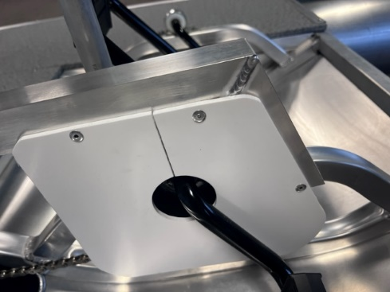
- Remove the white chain guard plate from the pedal crank shaft.
- Pull out the chain guard aluminum frame.
- Slide the new chain guard frame back into the correct position.
- Screw down the chain guard under the front seat first.
- Screw the chain guard in to the doghouse.
- Screw the chain guard to the front of the frame.
- Slide the new white chain guard plate on to the pedal crank assembly.
- Using the rivets supplied, rivet them in to the chain guard aluminum.
- Make sure that everything is tight and looks correct.
- Install the white front seat surface board with the screws.
- Put the front bottom seat cushion back on the boat.
***Note: If you notice a weird noise coming from the pedal crank assembly after replacing the chain guard, please make sure the white plate is not hitting the chain. If so, bend the plate outwards and the chain guard aluminum frame until it does not hit the chain.

