PADDLE KING
FEBRUARY, 2024
INSTALLATION OF THE DELUXE CONSOLE ON A LO PRO CRUISER
MEASUREMENTS:
- 5” OFF THE INSIDE OF THE WALL TO STERN (STARBOARD SIDE)
- 22” OFF THE INSIDE OF THE SEAT WALLS TO THE BACK OF THE STERN (STERN)
- 68 ½” OFF THE INSIDE OF THE FRONT WALL TO THE FRONT HELM (BOW)
USE A LARGE SQUARE TO STRAIGHTEN THE HELM
QTY OF SCREWS USED TO SCREW TO THE FLOOR: 3 (PRE-DRILLED HOLES LOCATED AT THE BOTTOM OF THE CONSOLE ON THE INSIDE OF THE FRAME)
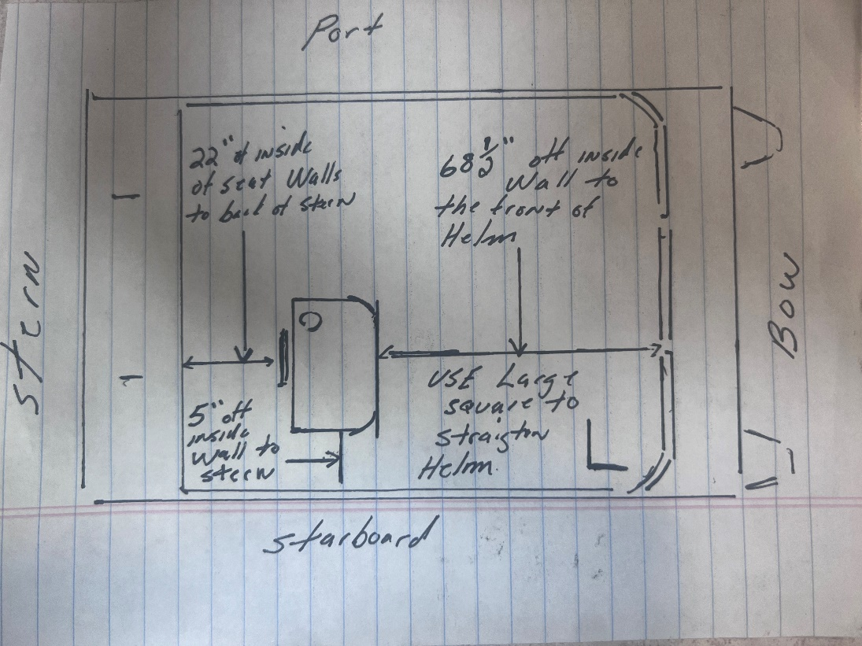

INSTALLATION OF THE CONSOLE STEERING CABLE ON A LO PRO CRUISER
MEASUREMENTS:
- 13” OFF THE INSIDE OF THE WALL TO THE CENTER (STARBOARD)
- 26 ½” OFF THE INSIDE OF THE REAR SEAT WALL TO CENTER (STERN)
- 75” OFF THE INSIDE OF THE WALL TO THE CENTER (BOW)
USE A 3” THICK HOLE SAW

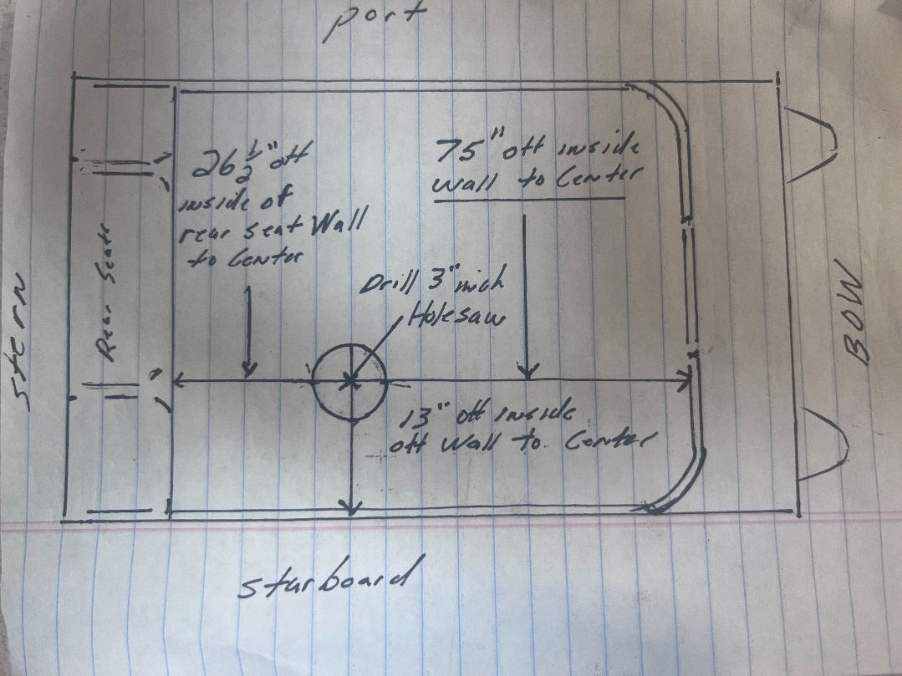
INSTALLATION OF THE DELUXE CONSOLE ON A LO PRO ANGLER
MEASUREMENTS:
- 5” OFF THE INSIDE OF THE WALL TO STERN (STARBOARD SIDE)
- 22” OFF THE INSIDE OF THE SEAT WALLS TO THE BACK OF THE STERN (STERN)
USE A LARGE SQUARE TO STRAIGHTEN THE HELM
QTY OF SCREWS USED TO SCREW TO THE FLOOR: 3 (PRE-DRILLED HOLES LOCATED AT THE BOTTOM OF THE CONSOLE ON THE INSIDE OF THE FRAME)

INSTALLATION OF THE CONSOLE STEERING CABLE ON A LO PRO ANGLER
MEASUREMENTS:
- 13” OFF THE INSIDE OF THE WALL TO THE CENTER (STARBOARD)
- 26 ½” OFF THE INSIDE OF THE REAR SEAT WALL TO CENTER (STERN)
USE A 3” HOLE SAW

Remove the glovebox to screw down the console.

