**CANOPY ASSEMBLY INSTRUCTIONS  
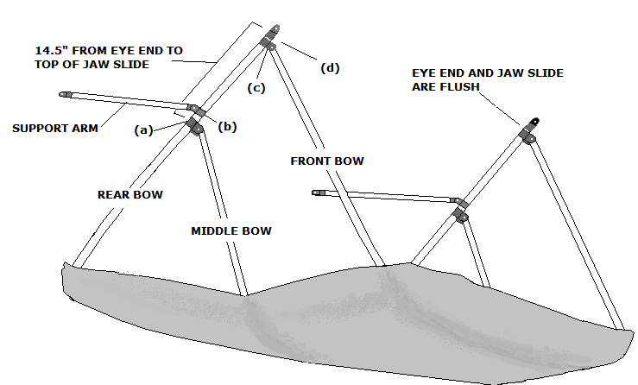**You will need a flat head screwdriver and measuring tape for the assembly.  
Please note that the label is in the rear of the canopy.

1. Unfold the canopy and set it on a flat surface with the “legs” pointing upward.
2. Slide the middle bow eye end into the rear bow jaw slide (a), insert large flat-head screw into the jaw slide and tighten. Do the same on the other side.
3. Slide support arm (b) down until it is flush with the rear bow bracket (a), making sure that set screw is pointing toward the canopy. Tighten the set screws (do not over tighten). Do the same on the other side.
4. Insert front bow end into the rear bow jaw slide assembly (c), tighten set screw. Do the same on the other side.
5. Slide one eye end into the end of the rear bow (d) and tighten set screw; flat side of eye end is parallel with front bow (the flat side would be parallel with the boat tubes).