Introduction

Thank you for purchasing a quality Paddle King product. Please take a few minutes to read this manual and become familiar with the boat features as well as some safe-boating tips.

If a friend or family member borrows your boat, please make sure he or she is fully aware of how to operate your boat, understands the rules of navigation, and all safety precautions and procedures. Remember, you are responsible for anyone who borrows your boat.

General Information

General Terminology:

Aft or stern: The rear or back of the boat.
Hull: The body of the boat.
Bow: The forward or front part of the boat.
Launch: To put a vessel in the water.
PFD: Personal floatation device or lifejacket.
Port: The left side of the boat if you are on the boat facing the bow.
Rules of the Road: The nautical traffic rules for preventing collisions on the water.
Starboard: The right side of the boat if you are on the boat facing the bow.
Underway: Describes a vessel in motion (not moored or anchored).
Capacity Plate: Your boat has a manufacturer’s capacity plate stating the maximum load in pounds (persons and gear) the boat can safely carry under normal conditions, and the maximum person capacity.
The number of persons listed on the capacity label is calculated solely by a formula based on the displacement of the tubes and not by safe boating practices. Boating conditions may require fewer occupants on board than indicated on the capacity label. Person capacity is based on an average of 141 lbs. each and ultimately the number of seats on the boat.

The operator of the boat is responsible for using common sense and good judgment when loading the boat. If the waters are turbulent, please use extra care. Remember that overloading and improper distribution of weight are major causes of accidents. Keep the weight below maximum limits for safety in turbulent waters. Overloading is a violation of U.S. Coast Guard regulations.

Hull Identification Number/Serial Number: Your boat has a hull identification number, which is located in the stern (rear) of the boat by the transom. There is also a plate that is underneath the deck in the middle. Federal law prohibits removal or tampering of this number in any way. Keep a record of this number in a safe place so that if your boat is stolen, you can report this number to the local authorities and your insurance agent.

Registration: All boats that have an engine or motor and are operated on navigable waters of the United States must be registered in the owner’s state. Contact your local Secretary of State office for requirements.

Warranty: Your new Paddle King boat is backed by a limited warranty. The complete warranty is printed in the back of this booklet. It is the dealer’s responsibility to go over the terms of the warranty. It is the owner’s responsibility to fill in the warranty registration card (provided with this booklet) and send it in within 30 days of purchase. You can also register on-line at www.paddleking.com (click on “Warranty Registration” at the bottom of home page). By registering your warranty, you are indicating that you are aware of the terms and conditions of the warranty.
Insurance: The owner of the boat is legally responsible for any damages or injuries caused by the boat. This is true in most states even if someone else is operating the boat when an accident happens. You should carry adequate personal liability and property damage insurance on your boat, just as you do on your automobile. This will also protect your investment against damage or theft.
What You Need to do Before Launching Your New Paddleboat

1. We recommend that you oil the following parts with a white lithium grease or WD-40 spray oil: drive chain, steering shaft, front and rear pedal shafts with 6 pillow block bearings (3 on the front pedal shaft, 3 on the rear pedal shaft).
2. You may want to treat any canvas or vinyl (such as seat cushions and canopy tops) with a good UV inhibitor spray. Have your dealer recommend one made especially for marine canvas and vinyl.
3. If you live in a very humid area, or if your boat is moored in the shade, you may want to lightly spray the carpet down with a solution of water and vinegar. This should be done twice a year.
4. The seat backs can be adjusted by three inches. See the diagram in the back of this booklet for instructions on how to adjust the seat back.
Caring for Your Boat

Taking good care of your boat will assure that your boat will look new, year after year. We recommend that you do not moor your boat under trees, as this may cause debris to be collected. Covering your paddleboat when not in use will keep your boat looking its best, and you may want to consider this if you live in the southern states or if your boat gets a lot of direct sun, but it is not necessary. Paddle King products are built to withstand years of use, especially if the seat cushions and canopy are treated with a UV inhibitor every year.

- The steps below should be performed at the beginning and the end of each boating season or whenever needed:
The drive chain has been coated to prevent rust. It is likely that the chain will rust in time, but with some chain oil it will perform for many years. We recommend a spray-grease such as white lithium.
- Steering shaft bushings should be sprayed with fine oil such as WD-40.
- Front and rear pedal shafts with 6 white pillow block bearings (3 on the front pedal shaft, 3 on the rear pedal shaft) should be oiled with white lithium grease.
The following is guide of how to clean and maintain certain surfaces of your boat:

Tube Maintenance: There are several pontoon tube cleaners and polishers on the market that will brighten up your tubes, such as “Toon-Brite”, available at marine stores (such as West Marine). Use these types of cleaners with care as they may contain acid. First, use a brush to remove any algae or scum on the tubes. It is easier to clean when wet. Always follow the instructions and precautions on the labels of any cleaners. If an aluminum tube gets punctured, it will need to be fixed and welded by a professional welder. Contact your dealer for referrals.

Seat Cushions: If seat cushions are wet for long periods of time, you may want to remove them and dry them out completely since water can eventually seep into seams. When necessary, clean the vinyl cushions with a mild soap and water, allow them to dry, then treat with a UV inhibitor for vinyl. You may be able to find a marine product that both cleans and contains a UV inhibitor. Suntan lotion, insect repellants and any other types of chemicals can cause stains--clean vinyl as soon as possible if chemical contact occurs. You can lubricate snaps with petroleum jelly. Do not clean seats with any cleaners containing “orange” as these products will sometimes strip the color or finish off.
Canopy and Mooring Cover: Periodically clean your canvas or boat cover to remove dirt and dust by wetting the article down completely and scrubbing with a mild soap and soft-bristle brush. Never use bleach or harsh detergents. Allow to dry then spray with Lysol or other disinfectant, or a solution of water and vinegar to prevent mildew. You may want to spray the topside of the canopy and mooring cover with a canvas UV inhibitor. We use products from the 303 line of cleaners and protectants. The snaps can be lubricated with petroleum jelly.
Floor Coverings: Keep carpet or vinyl clean by sweeping with a broom or vacuum. Clean when necessary with a diluted household cleaner and warm water or vinegar and water and a scrub brush. Rinse thoroughly and allow it to dry completely before covering or storing. Spraying the carpet with a solution of vinegar and water a couple times a year will prevent mold, algae, or moss from growing.

Salt Water Use: Our boats are intended for fresh water use. If you plan on using your boat in salt water, we suggest that you contact your dealer for a recommendation on an anti-fouling saltwater paint to use on your tubes. You may want to remove the boat from the water every month and rinse it down completely with fresh water. Clean the hardware and spray with a corrosive inhibitor every month.

Other surfaces: Wipe clean with a solution of vinegar and water or a light solution of a household cleaner and water. Read instructions on cleaning solutions to make sure they are appropriate for use on whatever surface you are cleaning.

Winterization and Storage

By following some simple procedures, you can extend the life of your boat. This section includes some general information about storing your boat after the boating season is over.

Preparation for storage: Indoor storage is ideal, especially in areas where ice and snow accumulate. If you store your boat indoors, make sure the facility has adequate ventilation. If storing your boat outdoors, cover it with a canvas cover and provide ventilation to keep moisture from building up inside. A snap-on mooring cover can be purchased from Paddle King or from your Paddle King dealer. This cover is ideal for storage.

Before preparing your boat for winter storage, thoroughly check the condition of the boat. It is a good time to perform all annual cleaning and maintenance and any necessary repairs. Please note that damage due to improper storage will void the warranty.

The best way to lift your boat out of the water is to load it onto your trailer. If a trailer is not available, arrange to have a marina lift your boat out of the water. Workers at the marina know the proper way to lift your boat and have the proper equipment available.

Please note: Any “U” bolts or mooring hooks on tubes are to be used only for mooring. Attaching lifting lines at these points will damage the tubes. Do not drag the boat up onto the shore, as this can tear off the steering shaft assembly. Also, never pull or push the boat by applying force to the seat backs.

Clean your boat, as described above, and allow to dry completely before covering and storing for the winter. Seat cushions and canopy tops are best stored inside, if possible.

Supporting Your Boat During Storage: Your boat’s trailer provides ideal support whenever it is not in the water because it supports the boat under the main frames.
If your boat is not stored on the trailer, it may be supported by several old tires equally distributed under the pontoon tubes. Make sure it is well supported! It is best not to let the boat set directly on the ground, as the soil may be acidic, which could corrode the tubes.

Getting Underway
Steering: Get used to the feel of how your boat steers. The responsiveness of the steering depends greatly on the water and wind conditions and the loaded weight on your boat. The boat actually turns sharper when the handle is turned about 90% of its total turning radius. Also, if you can’t quite make that sharp turn you are trying to make, stop, back up slightly, then attempt the turn again.
Loading Passengers and Gear:
- Board passengers one at a time. They should step and not jump onto the boat.
- No one should ever step directly on the pontoon tubes!
- All passengers should be seated in a seat and not allowed to sit on the deck or dangle their feet in the water from the bow. Falls from moving boats are a major cause of marine accidents.
- Make sure passengers sit so that there is an equal distribution of weight. Overloading and improper distribution of weight are significant causes of accidents. Capacity plates, located in the rear of the boat, specify maximum load capacity under normal conditions. Keep weight below maximum limits for safety in turbulent waters. Overloading is a violation of U.S. Coast Guard regulations. Boats under 20 feet (6.1 m) are subject to U.S. Coast Guard safe loading and labeling requirements. The following is the safe-load and person capacity on each of the paddleboat models: PK3000 520 lbs./ 2 persons; PK4400 830 lbs./4 persons.
- Make sure all passengers are seated correctly on the seats and not standing up. Passengers should remain seated when the boat is underway or away from the dock.
- Secure all gear firmly so that it will not interfere with boat operation.

General Rules of Seamanship:
- Respect the rights of boaters engaged in swimming, water skiing, diving or fishing. Never get near a water skier or someone being pulled behind a boat.
- Take extra caution if your lake is extremely busy with a lot of boat traffic. You may not be as visible to other boaters as a larger boat. You should try to obey the usual direction of traffic, which is normally counter-clockwise on inland lakes; however, it is sometimes advisable to “hug” the shoreline when the lake is very busy with other boats.
- Right of Way: In general, boats with less maneuverability have the right-of-way over more agile craft. Since a paddleboat is not considered to be the most “agile” of crafts, you would most likely be considered as having the right of way in most situations involving other boats that are under power, with the possible exception of sailboats.
- Boating Regulations: The local Sheriff Marine Patrol, local Coast Guard office, or state Department of Natural Resources (DNR) is responsible for enforcing boating regulation. Their goal is to help the boating public. You are subject to marine traffic laws and the “Rules of the Road” for both federal and state waterways; you must stop if signaled to do so by enforcement officers. The “Rules of the Road” can be obtained from your local U.S. Coast Guard Unit or the United States Coast Guard Headquarters by calling (202) 512-1800, and asking for the publication titled “Navigational Rules, International-Inland.”

Docking:
- Always approach the dock slowly. If possible, come in against the wind or current, whichever is stronger.
- If wind or current is moving toward the dock, move parallel to the dock further out. Let the wind or current push you in. Use extreme caution when the wind or current is from your stern.
- It may be useful to use a telescoping docking hook. You should stay seated while grabbing the opposite side of the dock with the hook and pull the boat parallel to the dock.

- Mooring and Anchoring: After you have positioned your boat next to the dock, you must secure it with mooring lines to the bow mooring eyes then the stern mooring eyes to keep it in position-- never use the handrails or canopy frame. An eye splice at the end of each line works well with bow and stern mooring eyes. If anchoring without a dock, make sure you use both bow and stern mooring eyes. It is advisable to remove or fold up the canopy top when mooring. Be sure to use a couple fenders or bumpers to protect the boat from damage by slamming up against the dock. If possible, tie up with the bow towards the waves. Use a good-quality double-braided nylon line. Make sure there isn’t a lot of slack in the mooring lines and the boat is snugged up against the fenders. Slack in the lines could cause the boat to be pulled and pushed back and forth in a strong wind and could tear the mooring eyes off the tubes.

- If you cover your paddleboat with a mooring cover, make sure the boat is dry before covering it. You can purchase a snap-on mooring cover from your Paddle King dealer or from Paddle King directly.

Note: You should also not moor your boat near ungrounded electrical current, as this could cause corrosion of the tubes. Such current sometimes comes from improperly grounded power sources near the water, such as water pumps or nearby boats linked to shore power.
Safety

You should become familiar with some basic safe operating procedures contained herein. Before getting underway, make sure you have all required safety equipment on board and that all passengers know where it is and how to use it. You should also periodically inspect all equipment to make sure it is in good working condition.

Required Equipment: These are the U.S. Coast Guard MINIMUM requirements for manually propelled recreational vessels less than 16 feet in length:
EQUIPMENT | CLASS A (LESS THAN 16 FEET)
Personal Floatation Devices | One Coast Guard approved Type I, II, or III PFD must be worn by each person on board.
Bell, Whistle | An efficient sound producing device to signal intentions or to signal your position during periods of reduced visibility.

Personal Floatation Devices (PFDs): PFDs have to be in good condition, legibly marked with the Coast Guard approval number, and of the appropriate size (in regard to the weight range and chest size marked on each PFD) for each person on board. Always check your older PFDs for buoyancy every year. We recommend always carrying a throwable (Type IV) PFD as well as wearing one.
Type II wearable PFDs are for calm, inland water, or where there is a good chance of fast rescue. It turns some unconscious wearers face up in the water. This type of PFD is typically orange in color and inexpensive.

Type III wearable PFDs are good for calm, inland water, or where there is a good chance of fast rescue. It has little or no turning ability. The wearer may have to tilt head back to avoid going face down. It has the same buoyancy as the Type II PFD. Type III PFDs are typically used for recreational water skiing and water sports.
Type IV is a throwable device. These are usually cushions, rings, or horseshoe buoys and are thrown to a person in the water, grasped and held by the user until rescued.
Pay special attention to children on board and make sure they have the correct PFD for their age/weight/height. We feel Type II PFDs (which will usually turn the child over on his/her back if unconscious) are the best. They can be purchased with crotch strap for children weighing up to 90 pounds from Overton’s catalog. The website, www.uscgboating.org, says, “Many adults believe themselves capable of diving into the water to rescue a child who falls overboard. This is a dangerous misconception. Adults may not notice a child falling overboard right away. Children who fall in may not surface immediately. It can be difficult to locate a child in the water—especially when the vessel is in motion. Life jackets could prevent approximately two-thirds of all boating-related drownings of children ages 14 and under. In fact, in most states, children under 13 must wear life jackets. It’s the law.”
Passenger Safety: All passengers should wear a life jacket (PFD) and shoes that provide traction on wet surfaces and provide protection. Passengers should remain seated when underway. Do not allow passengers to drag their hands or feet in the water. All riders should keep their hands and feet away from the drive chain. You should consider the water temperature before taking your boat out, especially in the spring and fall months, or if your lake or waterway water temperature never warms above 70 degrees. Hypothermia can set in very quickly in cold water. Wearing a lifejacket can help an overboard person remain afloat until help arrives. For more information and first aid for hypothermia victims, visit: http://www.seagrant.umn.edu/coastal_communities/hypothermia
For more information on boating safety, please visit the U.S. Coast Guard website at: http://uscgboating.org.
No one should ever step out onto the tubes, dive from the boat, stand up while the boat is in motion, or (on the PK3000) sit on the back area behind the seat.
Visual Distress Signals: Paddleboats are not required to carry day signals but must carry night signals when operating from sunset to sunrise. Since Paddle King paddle boats are not equipped with any type of navigation lights required for night running, we recommend that you do not take your paddleboat out after sunset.
Additional Gear and Equipment: You may want to consider carrying some of the following equipment and gear, depending on your needs: first-aid kit, sun block lotion, boat hook, mooring lines, flashlight, oar or paddle, and of course, your cell phone or a two-way walkie-talkie. Waterproof pouches can be purchased at most retail marine stores, such as Boaters’ World or West Marine.
First Aid: As a boat owner, you should be familiar with basic first aid. In addition to minor cuts and fish hook accidents, you should know how to give mouth-to-mouth resuscitation, know what to do for excessive bleeding, hypothermia and burns. First aid literature and courses are available through the Red Cross.
Operation of Boat by Minors: Minors should always be supervised by an adult whenever operating a boat. Please check your state’s laws regarding the minimum age and licensing requirements of minors.
Trailering
We recommend you use a Paddle King trailer to trailer your paddleboat. This trailer is specially made to accommodate your Paddle King paddleboat. Please refer to the “Trailering” section of the “Pontoon” guide book for specific details on how to load and trailer the boat. You should take off the canopy, seat covers, lifejacket cover, table, drinkholders, and any other accessories that you have added, before you trailer the boat.
Trouble Shooting

Squeaking noise: The 3 bearings in the front and 3 in the rear (under the boat) may need to be oiled with a white lithium spray grease or water-resistant spray grease. The pedals may also need to be oiled (spray grease on both sides of each pedal). Also, see “Loose drive chain…” below, which could cause noise.

Boat seems to pedal hard: First, check for weeds wrapped around the rear shaft. Also, the drive chain may need to be oiled. Use a good-quality white lithium spray grease and spray chain over the crank shaft as the chain is moving, so that the entire chain gets coated. You may also want to grease the 6 bearings (see above).

Steering problems: The wind and water conditions play a big factor in the ability of the boat to steering the right direction. If your boat does not seem to steer correctly, even in calm conditions, you may need to tighten the collars directly below the steering handle (refer to diagram for front steering assembly). Using a good allen wrench, apply a good amount of pressure to small set screws in the collar. If that does not do the trick, take the collars off and make sure the bolts are directly lined up with the grooved surface in the solid shaft. Re-tighten the collars again. You should also make sure your front and rear rudders are pointing to opposite pontoons when the steering handle is turned to one side. If you continue to have problems, please call the factory at (989) 235-6776.

Loose drive chain or drive chain came off completely: Any new chain will eventually stretch, creating slack in the chain. This could result in slapping noise of the chain or the chain completely coming off the sprockets. To tighten the chain, loosen six nuts on the rear shaft and slide the shaft back until chain is tight, making sure the front shaft is parallel to the rear shaft. If chain continues to come off, there may be a warped or bend sprocket. This can be fixed by lightly tapping on the warped or high side of the sprocket with a rubber mallet while slowly spinning the pedal assembly and eyeing both sprockets to make sure both sprockets are running in line.

Boat seems to list to one side: If boat is listing, check for pitting or punctures in the tube. This would allow water to enter the tube. If this is the case, you will have to have the tube repaired by a weld shop and then pressure tested. If the problem was pitted tubes, it is advisable to find the source of the pitting, so that it does not happen again. Chemicals used in the water (such as copper sulfate) or chemical run-off could be the problem. Also, improperly grounded electrical current from nearby shore power could cause electrolysis and pitting in the tubes.

Water is coming up underneath the seat assembly: This is normal is and caused by water hitting the deck underneath. You can completely dry the boat and use a waterproof silicone to seal around the seat base or wherever water is coming through.
If you are still experiencing problems, please feel free to contact the factory through our website’s contact form: paddleking.com

Statement of Limited Warranty

Paddle King, Inc., warrants each new boat (the product) it manufactures to be free from defects in material and workmanship, under normal non-commercial use and service for (2) years from the first date of retail purchase, with the exception of a three (3) year extended warranty on all welded parts and welded seams of the hull, and a lifetime warranty against rot on the wood decking, subject to the terms and conditions stated below:

- Warrantor: This warranty is granted by Paddle King, Inc., 7110 S. Crystal Road, Carson City, MI 48811.

- Parties to whom warranty is granted: This warranty is granted to the original retail purchaser when the boat is sold through an authorized dealer and is not transferable to any subsequent owner of that boat.

- Warranty covers parts and labor required by an authorized dealer. Shipping of the paddleboat is the sole responsibility of the customer unless a written authorization from the Paddle King president is obtained.

- Parts covered: all parts manufactured by Paddle King, Inc. and installation of parts, which are manufactured by Paddle King, Inc.

- Parts not covered: All parts that are not manufactured by Paddle King, Inc., such as: chains, bearings, plastic parts. These parts may have separate manufacturer’s warranty granted by the original manufacturer of the part.

- Proof of Purchase: a requirement of the Federal Boat Safety Act of 1971 provides for defect notification to the first purchaser. Failure to register your purchase with the manufacturer constitutes waiver of the right to defect notification. All warranty claims must be accompanied by a dated and signed bill of sale from an authorized Paddle King, Inc. dealer.

- Corrosion of the pontoon tubes due to any cause is not warranted. This includes, but is not limited to: exposure to chemicals which could cause damage to the aluminum tubes and parts. You should be aware of any chemicals that are being used to treat water that comes in contact with the boat, especially in ponds or small bodies of water, and read all chemical manufacturer’s instructions and precautions. Electrolysis (stray electric current) could also cause corrosion of the tubes.
Under the guidelines of this warranty, Paddle King, Inc., will repair or replace at our option, any boat or part(s) found to be defective in material or workmanship upon review at its Carson City, Michigan facility or by an authorized Paddle King dealer. Shipping and transportation costs of the boat are the sole responsibility of the boat owner.

No person or dealer, agent or representative of Paddle King, Inc., is authorized to make any representation of warranty concerning Paddle King, Inc.’s products on behalf of the company except to refer purchasers to this warranty.
Paddle King, Inc., will arrange for the repair or replacement of the defective part or parts on boats with properly registered warranty cards within 30 days of receipt of a claim. All claims must be accompanied by a copy of the original purchase invoice showing the date of purchase, the boat serial number and the name of the dealer. All claims must be pre-approved by Paddle King, Inc. prior to any repair work done on the boat. All warranty registration cards should be sent to:
Paddle King, Inc.
7110 S. Crystal Road
Carson City, MI 48811
Warranty Exclusions:

- Damage caused by mold, mildew, pink stain.
- Any maintenance or repairs required due to ordinary wear and tear on the paddleboat.
- Damage caused by non-factory installed items.
Damage to the tubes, mooring eyes, or any area around the mooring eyes.
- Associated damages claimed to be the result of fungus or termites.
- Damage caused by abuse, neglect, misuse, accident or acts of God.
- Any boat used for racing purposes, or modified in any way, other than upon written instructions from Paddle King, Inc.
- Any damage to the tubes, mooring eyes, or the area around the mooring eyes.
- Any boat subject to improper trailering or loading (including trailering with table, seat cushions, canopy top, or mooring cover still attached).
- Any boat used in commercial or rental use.
- Any boat with damage caused by use of chemicals.

Paddle King, Inc. retains the right to have a representative inspect all parts concerned with any claim initiated under this warranty.
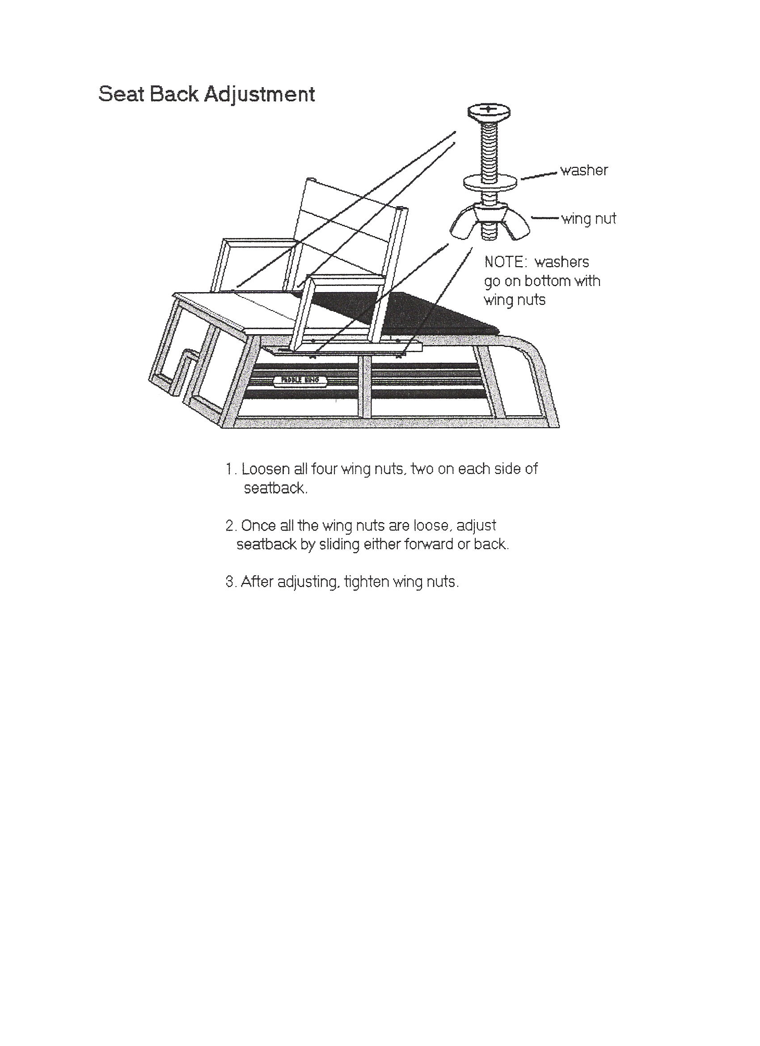

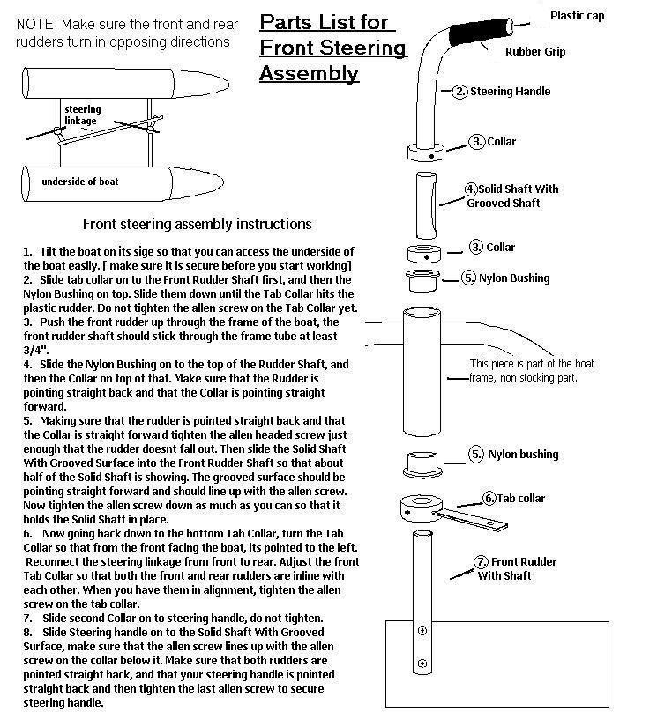

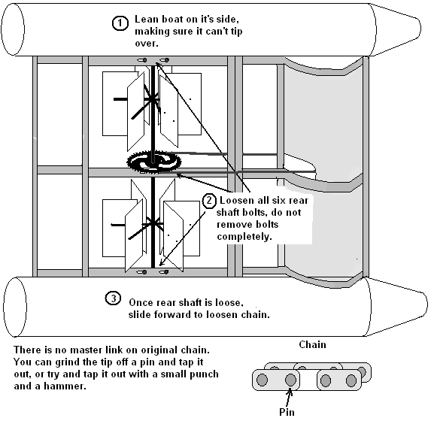

How to Install the Drive Chain
1. You will have to have the boat pulled up on land. Be careful not to drag it so that the rudders drag on the ground. You will need at least two very strong people to do this.
2. The boat should then be carefully tilted up on one side and leaned against a tree or have a couple people hold the boat so you can get to its underside.
3. If you are replacing an older chain, take chain off by grinding a stud off the chain and twisting it with vise grips.
4. You should then loosen the six bolts on the rear shaft.
5. Slide the rear shaft up toward the front (bow) of the boat and make sure the rear and front shafts are parallel to each other.
6. Put the new chain on the sprockets and loop it around to bottom where you can work on it.
7. If the chain is too long, you will need to take off one or more links (do a count to see how many need to be removed).
8. You will then need to file or grind the small round “nob” on the side of the leading link to remove the remaining links. The remaining links can be slightly twisted with vise grips to remove them.
9. You can now carefully install the chain over the sprockets and loop it around to the bottom, where you can attach the ends.
10. Add the “master” link (enclosed with your drive chain), to both ends to connect them, then add the link “washer” and the “clip” to secure.
11. If the chain is not tight, you can tighten it by loosening the 6 bolts on the rear shaft and pulling the shaft back slightly. This should tighten the chain.
12. Re-tighten the two center bolts, making sure the chain is still tight. Make sure the front and rear shafts are parallel.
13. Re-tighten the remaining 4 bolts (two on each side).
14. If the sprocket(s) is warped: gently tap the high side (where it is warped) with a hammer while someone is spinning the chain, until the sprocket is straight.


