How to Install the Lo Pro Mooring cover
Instructions:
***As you are installing the self-drilling screw studs, snap the mooring cover to them.
*** Please note that if you are replacing a mooring cover the snaps may not line up with the new cover.
- Open up the mooring cover and lay the cover over the boat matching the corners up. (There is a serial number wrote in white chalk on the inside of the cover. This is the front of the cover and should be placed in the center of the bow of the boat.)
- Check that the canopy rail-mounted brackets are centered in the pocket of the cover.
- Start at the front center of the boat by placing the notch in the cover around the winch u-bolt bracket.
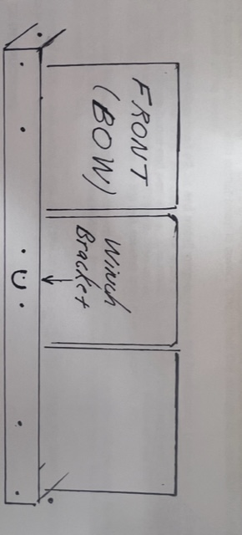
- Start installing the first self-drilling screw under the first line on the trim on both sides of the u-bolt. (Make sure the self-drilling screws are in line with the mooring cover snaps.)
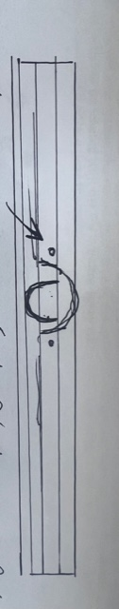
- Install the screw studs on each corner of the bow of the boat to align with the mooring cover snaps and placement of the two center screws. (Under the first line on the trim)
- Install two more screw studs on the bow of the boat aligning with the mooring cover snaps.
- Put clamps on the rear corners of the stern to hold the cover in place. 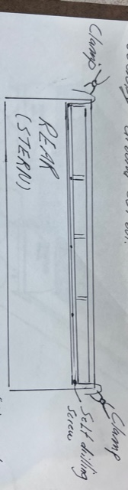
- Align the snap on the cover to the bottom rail on the stern of the boat.
- Install the screw studs on each corner on the stern of the boat.
- Install the center screw stud on the rear of the boat and one screw stud on each side in between the center and corner snaps.
- Once the bow and stern of the boat are complete, start at the front of the side rails on the port and starboard sides and work your work to the stern of the boat making sure that the screw studs are aligning with the existing snaps on the mooring cover.
Fitting the Lo Pro Mooring Cover with the Poles:
- Once the cover is installed on the boat and snapped, unsnap a couple of the front snaps.
- Crawl into the boat and place the mooring poles in the black vents. Adjust the poles so the mooring cover is tight.
- Crawl back out and snap the front snaps to ensure the cover fits tightly overall.
Maintenance:
Never store the mooring cover when it is wet or damp. Periodically clean and treat your cover. Remove any dirt and dust by brushing the cover with a soft bristle brush, then wet article and scrub using a mild soap. Never use bleach or harsh detergents. 303 is a great brand to clean and protect the cover with. Lubricate snaps with petroleum jelly. When the cover is completely dry, treat the outside with a UV inhibitor spray. This will also restore the water-repellency of the material and greatly increases the life of the cover.

